**VXLAN EVPN DATACENTER LAB**

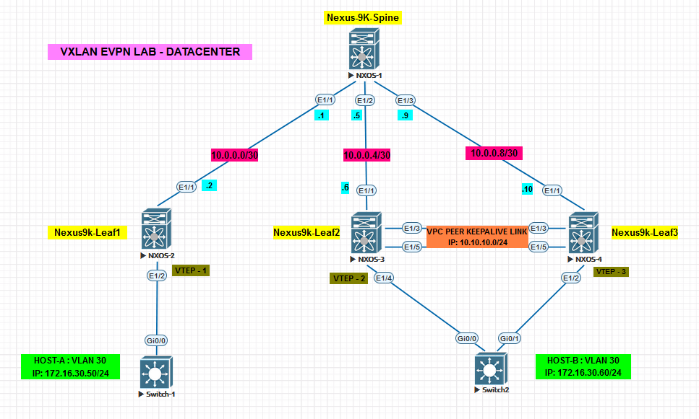

* The above given topology has 1 Spine and 3 Leaf Switches. Leaf 1 is in one physical network of datacentre, whereas Leaf 2 and Leaf 3 are present on the other physical network of the datacentre.
* 2 host switches have same Vlan 30 network. Host A is the Switch 1 in one part of datacentre and Host B is the Switch 2 which is at another part of Datacentre.
* Both Hosts are kept in the same network (same vlan) and communicate in spite of being geographically separated.
* This is possible due to VXLAN.
* Hence will we performing the below lab so that Host A and Host B communicate with each other.

**Initial Boot up of Nexus Switch:**

Please Follow the below mention steps for initial start-up of all 4 Nexus Switches

**Note: If you directly get login and password, then please don’t do the below loader prompt steps directly enter the username and password.**

**Loading process can take up to few minutes.**

**If loader prompt appears then follow the below given steps**

* Start the switch node and open its CLI.
* When the switch starts at initial boot up , you see the below screenshot

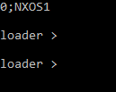

* Enter dir command to check the image file which will be required for booting the switch.

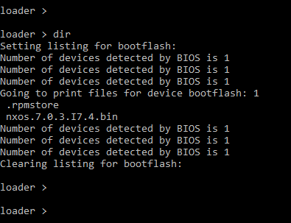

* You will see a .bin file that will be the image used for the Nexus switch. Enter the below given command.

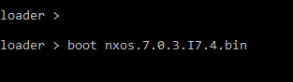

* Once the loading is done, it will prompt for username and password,
* Username 🡪 admin
* Password 🡪 cisco@123

Note: You might be asked to do the above steps again, if you do Stop All Nodes and close EVE-NG console and login again next time. Hence do not stop the nodes, keep them running, just close the browser, unless and until you finish and get final output.

**For saving configuration enter copy running-config startup-config do not enter write command**

1. **First we need to enable all the features such as OSPF, BGP, EBGP, Interface-Vlan etc. on Nexus Devices. Enable all the features in the global config as given below.**

**Note: VPC feature needs to enabled on Leaf2 and Leaf 3**

* feature ospf
* feature bgp
* feature pim
* feature fabric forwarding
* feature interface-vlan
* feature vn-segment-vlan-based
* feature nv overlay
* feature lacp
* nv overlay evpn

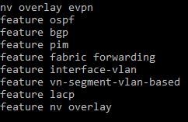

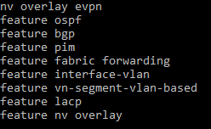

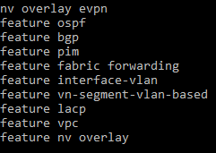

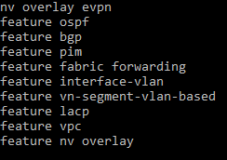

1. **Configure the Ip address on the Spine and Leaf according to the Topology. Also configure the loopbacks.**

* **On Spine Switch:**

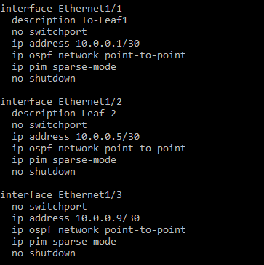

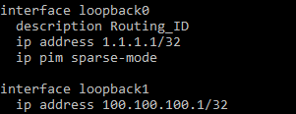

* **On Leaf 1:**

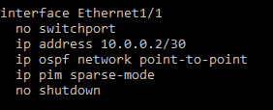

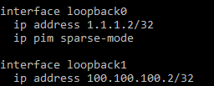

* **On Leaf 2:**

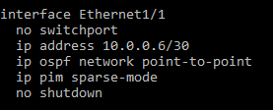

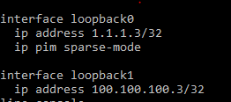

* **On Leaf 3:**

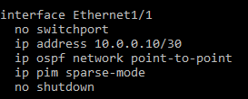

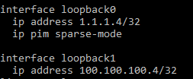

**Verifying IP Addresses:**

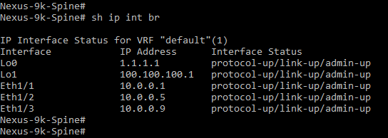

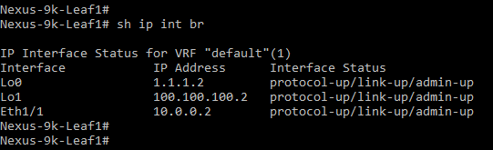

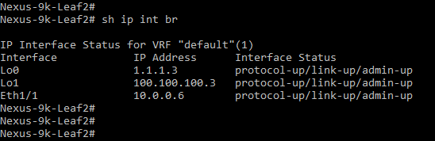

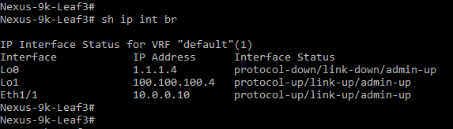

1. **Configure OSPF on Spine and Leaf nodes such they have a reachability. Advertise OSPF only on the nodes between Leaf and Spine**

* **On Spine**

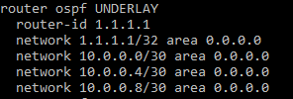

* **On Leaf 1:**

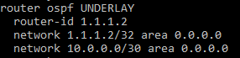

* **On Leaf 2:**

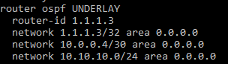

* **On Leaf 3:**

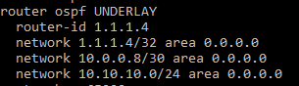

* **Verifying OSPF Neighborship:**

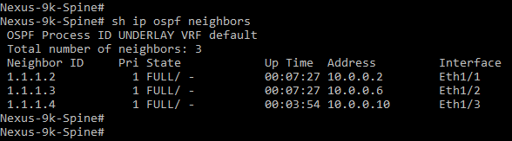

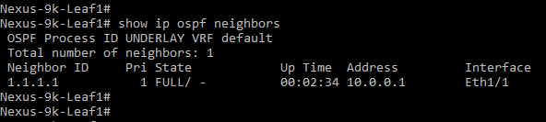

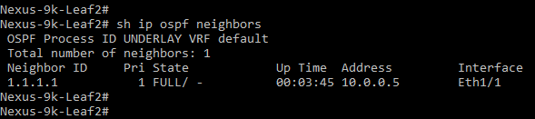

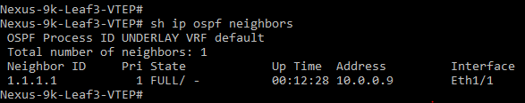

**PIM:**

* Protocol Independent Multicast (PIM) is a collection of multicast routing protocols, each optimized for a different environment.
* There are two main PIM protocols, PIM Sparse Mode and PIM Dense Mode.
* A third PIM protocol, Bi-directional PIM, is less widely used.
* Typically, either PIM Sparse Mode or PIM Dense Mode will be used throughout a multicast domain.
* However, they may also be used together within a single domain, using Sparse Mode for some groups and Dense Mode for others.
* This mixed-mode configuration is known as Sparse-Dense Mode. Similarly, Bi-directional PIM may be used on its own, or it may be used in conjunction with one or both of PIM Sparse Mode and PIM Dense Mode.
* All PIM protocols share a common control message format. PIM control messages are sent as raw IP datagrams (protocol number 103), either multicast to the link-local ALL PIM ROUTERS multicast group, or unicast to a specific destination.

#### **PIM Sparse Mode**

* PIM Sparse Mode (PIM-SM) is a multicast routing protocol designed on the assumption that recipients for any particular multicast group will be sparsely distributed throughout the network.
* In other words, it is assumed that most subnets in the network will not want any given multicast packet.
* In order to receive multicast data, routers must explicitly tell their upstream neighbors about their interest in particular groups and sources.
* Routers use PIM Join and Prune messages to join and leave multicast distribution trees.

1. **Configure Multicast using PIM (Protocol Independent Multicast). Before this OSPF configuration should be proper and neighborship should be up. Also configure fabric forwarding globally on all switches.**

* PIM Group-list and SSM (Source Specific Multicast) Range needs to be specified at global configuration mode on Spine and Leaf Routers
* PIM sparse mode needs to be enabled on Ethernet as well as loopback interfaces, the interface which face the spine
* **Spine**



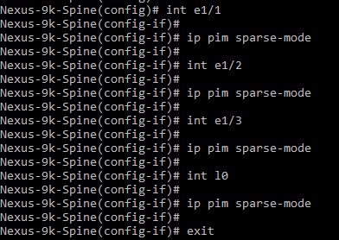

* **For Leaf 1, Leaf 2 and Leaf 3 (Screenshot for Leaf3 Attached)**



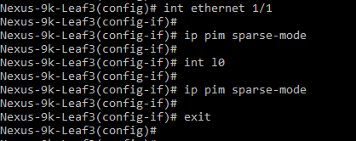

**Note: MAC address for each Leaf will be different, use cmd 🡪** **show mac address-table**

1. **Now configure VLAN’s locally on all the 3 Leaf switches. Also define the VNI (VXLAN Network Identifier)**

* **Leaf 1**
* Vlan 10 is used as a layer3 VNI to Route the Inter VNI traffic.
* VLAN 30 is used for the Host.

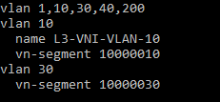

* **Leaf 2**
* Vlan 10 is used as a layer3 VNI to Route the Inter VNI traffic.
* VLAN 30 and 40 are used for the host

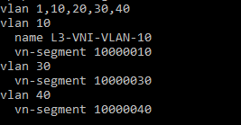

* **Leaf 3**
* Vlan 10 is used as a layer3 VNI to Route the Inter VNI traffic.
* VLAN 30 and 40 are used for the host

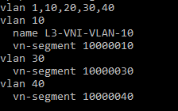

1. **Assign Layer 3 VRF for Inter-VNI Traffic.**

* **Leaf 1**

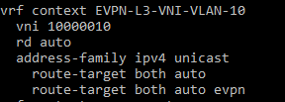

* **Leaf 2**

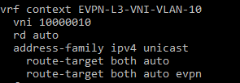

* **Leaf 3**

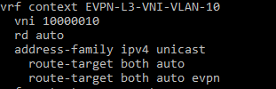

1. **Now assign Layer 3 gateway for VLAN 10, which is used to carry inter VNI traffic.**

* **Leaf 1**

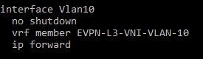

* **Leaf 2**

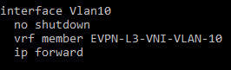

* **Leaf 3**

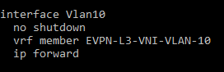

1. **Assign Layer 3 address to VLAN 30. Host A and Host B are both belonging to Vlan 30 on switch1 and switch2 respectively.**

* **Leaf 1**

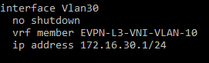

* **Leaf 2**

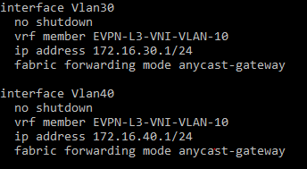

* **Leaf 3**



1. **Configure NVE (Network Virtual Interface) on all the 3 Leaf switches.**

* **Leaf 1**

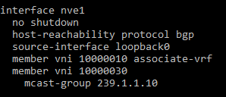

* **Leaf 2**

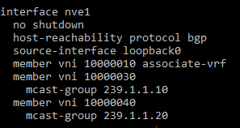

* **Leaf 3**

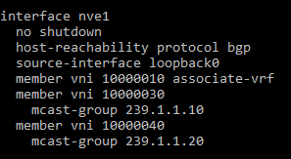

1. **Configure EVPN and setting RD and RT on all 3 leaf nodes.**

* **Leaf 1**

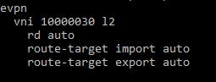

* **Leaf 2**

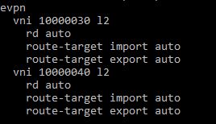

* **Leaf 3**

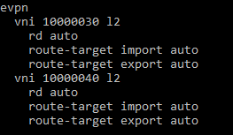

1. **Configure BGP between Spine and Leaf Nodes. Make Leaf Nodes as Route-Reflector Servers and Spine Node as Route Reflector client. Neighbors should be configured under EVPN address-family. Send extended Communities to neighbor. Also make sure EVPN is advertised under the L3-VNI-VLAN-10 that was configured earlier.**

**Do verify BGP connectivity between the Spine and Leaf nodes. Attach screenshot for all the 4 nodes**

* **On Spine**

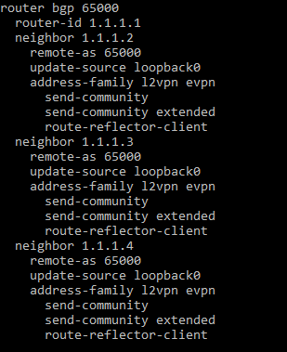

* **On Leaf 1**

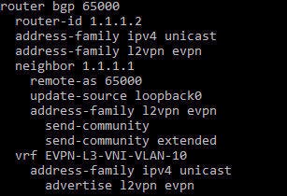

* **On Leaf 2**

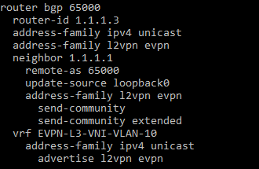

* **On Leaf 3**

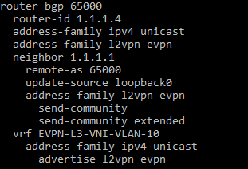

**Verifying BGP Connectivity:**

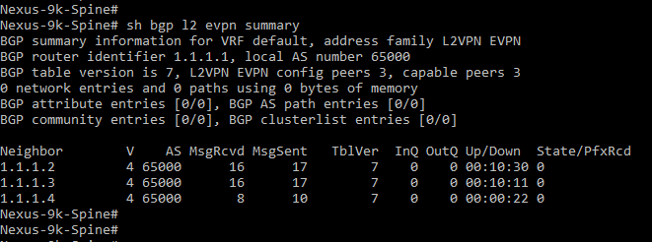

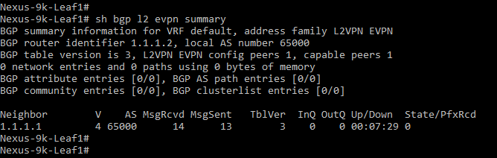

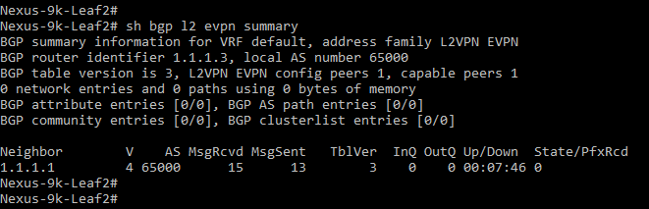

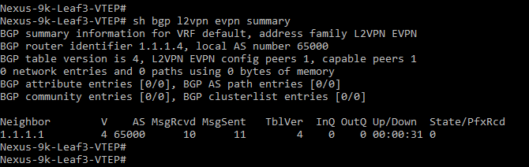

1. **Now configure Host A and Host B which are on Switch-1 and Switch-2 respectively. Assign IP address to interface Vlan 30. Also assign a default route pointing towards Leaf 1 and Leaf2/3 Vlan 30 interface.**

* **HOST A**

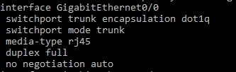





* **HOST B**

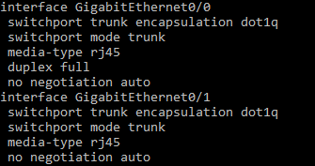





1. **Verify Interfaces and Routing tables on both Host A and Host B.**

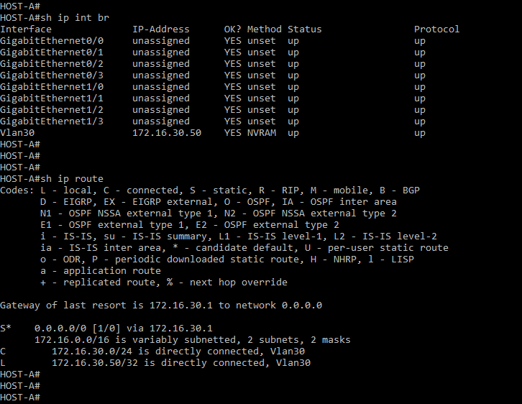

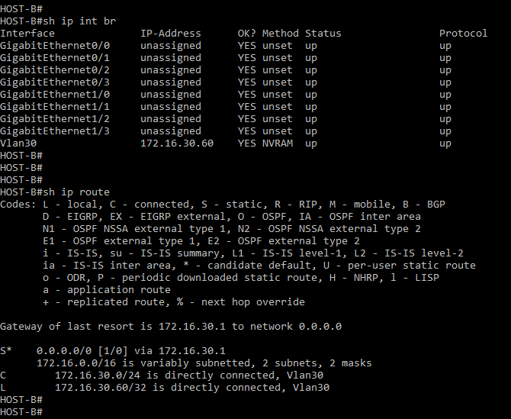

1. **Configuring VPC peering between Leaf2 and Leaf3. Also create a 2 port channels, one for vpc peer link and another for vpc 12. Configure the vpc peer port channel on link between Leaf 2 and Leaf 3. Also configure vpc 12 on the link between Leaf 2/3 and Switch 2.**

* **Leaf 1:**



* **On Both Leaf 2 and Leaf 3**



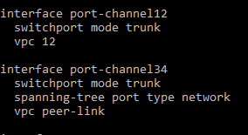

* **Leaf 2:**





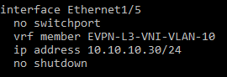

* **Leaf 3:**





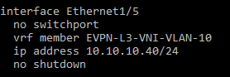

1. **Verify nve peering on all the 3 leaf nodes**.

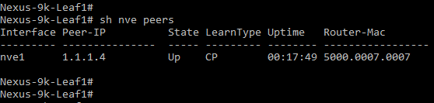

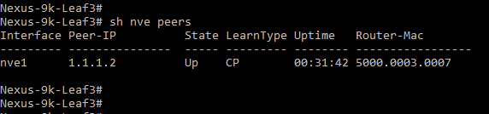

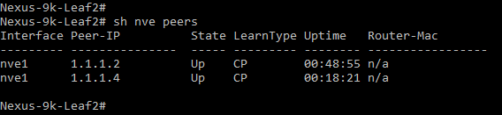

1. **Verify the bgp evpn routes on the Spine and Leaf Switches.**

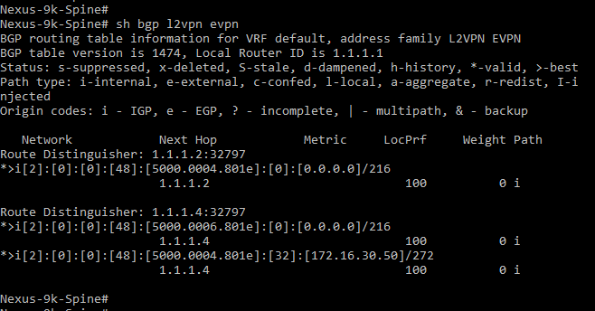

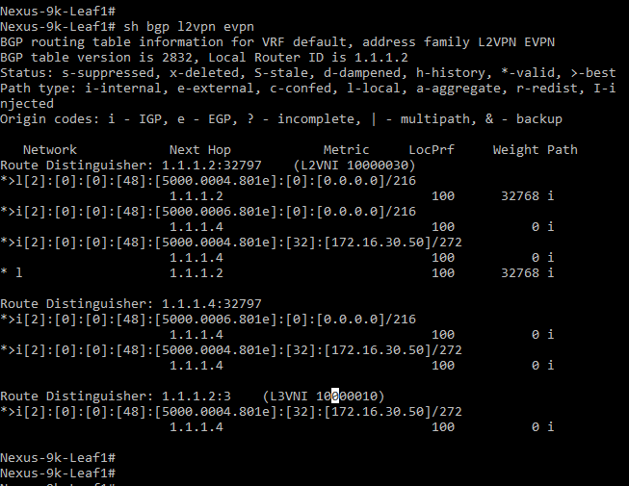

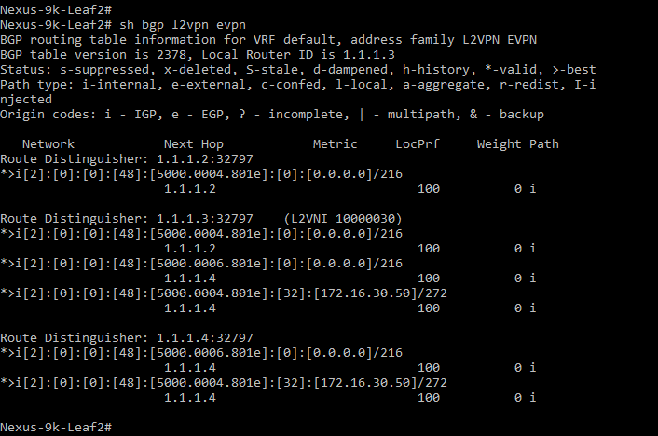

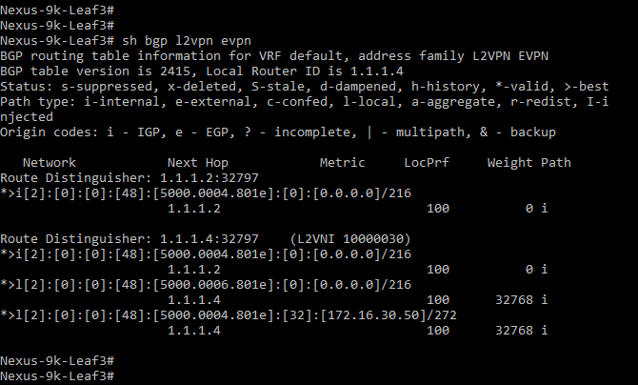

1. **Verify pinging from Host A to Host B.**

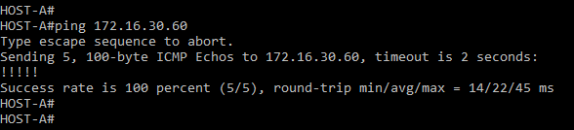

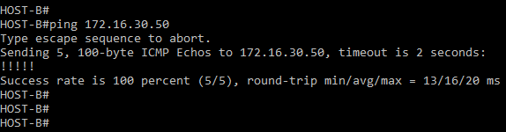

1. **Explain VXLAN in short. Why it is used? Also State its features.**

* VxLAN is concept on running Layer 2 networks over the Layer 3 networks.
* It creates a tunnel for L2 overlay on top of the L3 network.
* VxLAN works on L2 tunnelling and works on UDP, hence it is called as MAC-in-UDP.
* The basic idea of VxLan is to virtually extend the LAN across geographical boundaries, with the traditional IP network being used as an Underlay.
* **Features of VxLAN** –
* **Scalability:** Can support 16 million of vxlan’s and customer networks.
* L2 can be extended all over the globe and hence supports L2 segment Elasticity.
* Supports Equal Cost Multi Pathing in order to achieve optimal path.
* Leverages Multicast in order to simulate flooding for broadcasts.

1. **Explain VTEP, VNI and EVPN.**

* **VTEP:** This is an entity where encapsulation and decapsulation in the networks are done. It is used to map a L2 frame to VNI, so as to be used in overlay networks.
* **VNI:** VNI (VxLAN Network Identifier is and 24 bit field, which is used to uniquely identify a VxLAN. VNI is similar to VLAN ID, but VNI has 24 bits and hence you can create upto 16 million VxLAN’s.
* **EVPN:** EVPN (Ethernet VPN) is used for carrying L2 traffic virtually over L3 infrastructure. It supports Ethernet over VxLAN as well as Ethernet over MPLS.

1. **Explain difference between VXLAN and VLAN.**

* **VxLAN:** VxLAN is concept on running Layer 2 networks over the Layer 3 networks, where the LAN is virtually extended across geographical boundaries, with the traditional IP network being used as an Underlay.
* **VLAN:** VLAN is the concept of dividing the physical LAN network into virtual networks for the purpose of reducing broadcasts in the network which helps to improve network performance, less bandwidth utilisation and helps in easier management of the network.

Leaf 3:

peer-keepalive destination 10.10.10.30 source 10.10.10.40 vrf EVPN-L3-VNI-VLAN-10

Leaf 2:

peer-keepalive destination 10.10.10.40 source 10.10.10.30 vrf EVPN-L3-VNI-VLAN-10